

**“CHATTING APPLICATION”**

**JAGATPUR POST GRADUATE COLLEGE VARANASI**

***AFFILIATED TO MAHATMA GANDHI KASHI VIDYAPITH***

**(YEAR 2021-2022)**

**A Project Report**

***Submitted in partial fulfillment of the award of the degree***

***Of***

**BACHELOR OF COMPUTER APPLICATION**

**Submitted by: IN GUIDENCE OF :**

**Ankit Pathak DR.DHARM RAJ SINGH**

**Ram Prakash Sharma ASSISTANT PROFESSOR**

**Divyansh Kumar Upadhyay** **(HEAD Of DEPARTMENT )**

**ROLL NO: -**11040207069 BCA JAGATPUR

**ACKNOWLEDGEMENT**

The satisfaction that accompanies that the successful completion of any task would be incomplete without the mention of people whose ceaseless cooperation made it possible, whose constant guidance and encouragement crown all efforts with success.

We are grateful to our project guide Dr. Vijaykant Sharma and Dr. Dharm Raj Singh for the guidance, inspiration and constructive suggestions that helpful us in the preparation of this project.

We also thank our colleagues who have helped in successful completion of the project.

**ANKIT PATHAK**

**RAM PRAKASH SHARMA**

**DIVYANSH KUMAR UPADHYAY**

**JAGATPUR POST GRADUATE COLLEGE**

***(AFFILIATED TO MAHATMA GANDHI KASHI VIDYAPITH )***

**CERTIFICATE**

This is to certify that the project entitled “CHATTING APPPLICATION”, is bonafied work of ANKIT PATHAK , RAM PRAKASH SHARMA,DIVYANSH KUMAR UPADHYAY, submitted in partial fulfillment of the requirements for the award of degree of BACHELOR OF COMPUTER APPLICATION from MAHATMA GANDHI KASHI VIDYAPITH.

IN GUIDANCE OF :

**Dr. VIJAYKANTH SHARMA**

**BACHELOR OF COMPUTER APPLICATIONS**

**3rd YEAR**

**ANKIT PATHAK**

**RAM PRAKASH SHARMA**

**DIVYANSH KUMAR UPADHYAY**

**DECLARATION**

# I hereby declare that all the things are made by my group with all their knowledge and dedication towards the project and with a great support of our project guide Dr. Dharm Raj Singh .

# Table of Contents:

**ABSTRACT**  (6)

**INTRODUCTION** (7)

**MAIN OBJECTIVE** (8)

**REQUIREMENT** (9)

**DFD**  (12)

**ER DIAGRAM** (13)

**PROJECT SCOPE** (14)

**THE SERVER** (15)

**THE CLIENT** (17)

**FUTURE SCOPE** (21)

**CONCLUSION** (22)

**BIBLIOGRAPHY** (23)

# *ABSTRACT*

Teleconferencing or chatting refers to any kind of communication that offers a real-time transmission of messages from sender to the receiver. Chatting is a method of using technology to bring people and ideas together despite the geographical barriers. The technology to provide the chatting facility has been available for years, but the acceptance is quite recent. Analysis of chatting provides an overview of the technologies used, available features, functions, system of the architecture of the application, the structure of database of an Instant Messaging application: IChat(IC). The objective of IC application is to facilitate text messaging, group chatting option, data transfer without size restriction which is commonly seen in most of the messaging application.

## **INTRODUCTION**

**PURPOSE :-**

Chatting Application is a desktop based application.

This client server chat application is based on java swing and used socket package. It is simple and easy and require only core java knowledge. I have tried to modified a little bit to make it simpler and more elegant.

This application/program is a good example of using java.io, java.net package to create a chat application. A beginner of java language, who is familiar with this packages can able, be beneficiate.

Chatting is a method of using technology to bring people and ideas “together” despite of the geographical barriers. The technology has been available for years but the acceptance it was quit recent. Our project is an example of a multiple client chat server.

It is made up of 2 applications the client application, which runs on the user’s Pc and server application ,which runs on any Pc on the network. To start chatting client should get connected to server. We will focus on TCP and UDP socket connections which are a fundamental part of socket programming.

**Keywords:-**

Sockets, client-server, Java network programming-socket functions, Multicasting etc.

**Technology used:-**

**Operating System:-** windows 10 home .

**IDE used:-** NETBEANS version 8.

**JDK :-** JDK 8.

**Language:-** Core Java ,Swing , AWT, Event Handling ,Socket programing .

***MAIN OBJECTIVE***

The aim of this project is to express how we can implement a simple chat application between a server and a client? The application is a desktop based application and is implemented using Swing and awt. The project is developed in Java SE language executed on a single stand-alone java across a network using loop back address concept.

**Application consists of two programs:**

**Server**

The server module of the application waits for the client to connect to it. Then if connection is granted a client interacts communicates and connects to the server, it can mutually communicate with the server. The duty of the server is to let clients exchange the messages.

**Client**

The client module is the one that utilizer sends requests to the server. Utilizer utilizes the client as the means to connect to the server. Once he establishes the connection, he can communicate to the connected server.

## ***REQUIREMENTS***

##### External Interface Requirements

**User Interface**

###### The user interface required to be developed for the system should be user friendly and attractive.

There are two sets of Java APIs for graphics programming: AWT (Abstract Windowing Toolkit) and Swing.

###### AWT API was introduced in JDK 1.0. Most of the AWT

components have become obsolete and should be replaced by newer Swing components.

###### Swing API, a much more comprehensive set of graphics

libraries that enhances the AWT, was introduced as part of Java Foundation Classes (JFC) after the release of JDK

1.1. JFC consists of Swing, Java2D, Accessibility, Internationalization, and Pluggable Look-and-Feel Support APIs. JFC was an add-on to JDK 1.1 but has been integrated into core Java since JDK 1.2.

##### Software Interfaces

**Programming Language** :-JAVA AND SOCKET PROGRAMING

This project describes a very basic one-way Client and Server setup where a Client connects, sends messages to the server and the server shows them using a socket connection. There’s a lot of low-level stuff that needs to happen for these things to work but the Java API networking package (java.net) takes care of all of that, making network programming very easy for programmers.

**Operational Concepts and Scenarios**

Operation of the application based on the inputs given by the user:

* When the run button is clicked then the chat form is initialized with a connectionbetween the host and the client machine.
* **Note:** server must be started at first before a client start.
* Contains a rich textbox which send messages from one user to another

Contains a textbox for messages to be written that is sent across the network.

Contains a Send button

* When the sent button is clicked, in the background, the text in the textbox is encodedand sent as a packet over the network to the client machine. Here this message is decoded and is shown in the rich textbox.

**DATA FLOW DIAGRAM :-**

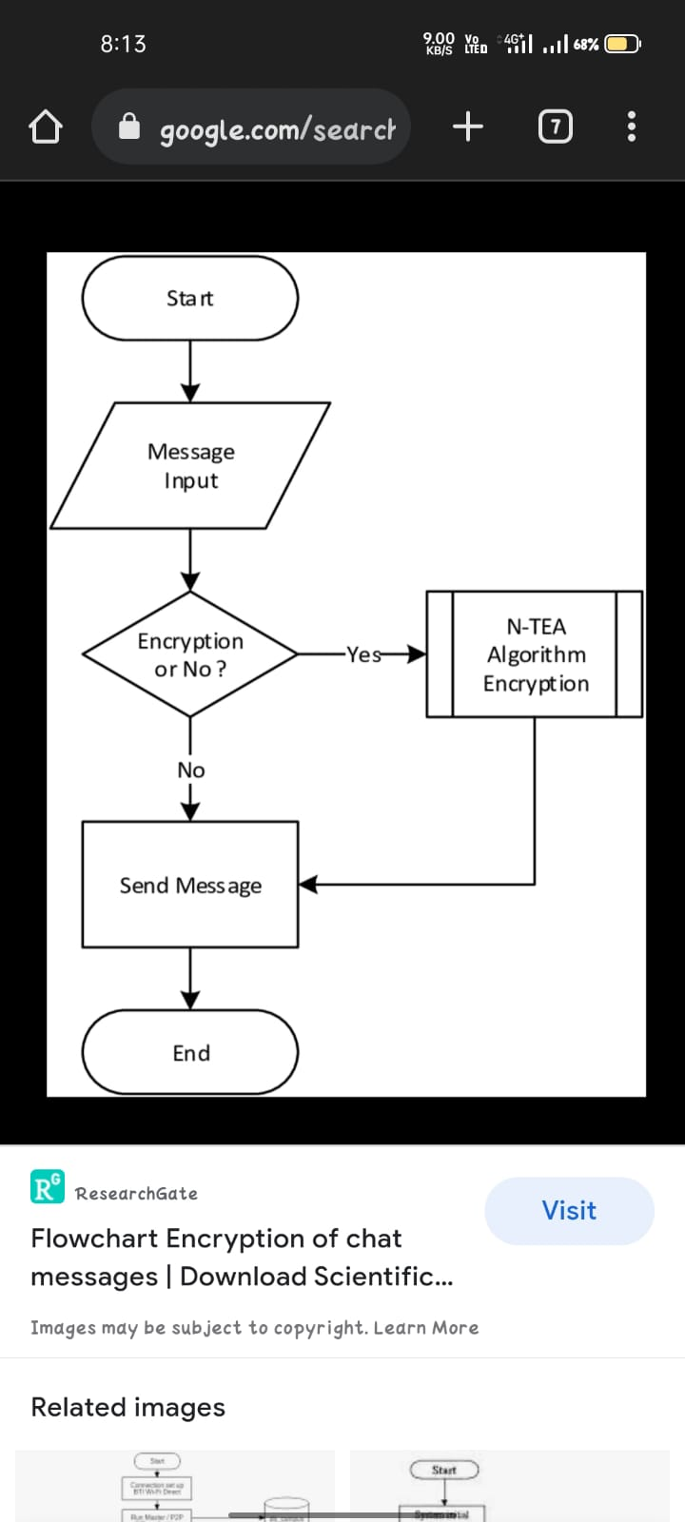

**Entity Relationship Diagram:-**

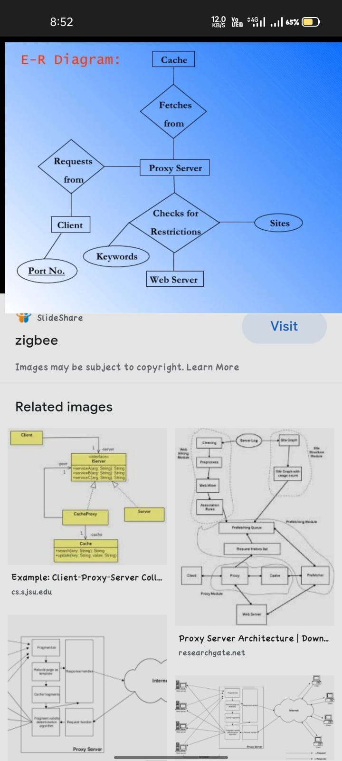

## ***Project Scope***

This project can be mainly divided into two modules:

1. Server
2. Client

This project is mainly depended on client/server model. The client requests the server and server responses by granting the clients request. The proposed system should provide both of the above features along with the followed ones:

###### ***Server***

A server is a computer program that provides services to other computer programs (and their users) in the same or other computers. The computer that a server program runs in is also frequently referred to as a server. That machine may be a dedicated server or used for other purposes as well. Example Server, Database, Dedicated, Fileserver, Proxy Server, Web Server. The server is always waiting for client’s requests. The client come and go down but the server remains the same.

A server application normally listens to a specific port waiting for connection requests from a client. When a connection request arrives, the client and the server establish a dedicated connection over which they can communicate. During the connection process, the client is assigned a local port number, and binds a socket to it. The client talks to the server by writing to the socket and gets information from the server by reading from it. Similarly, the server gets a new local port number (it needs a new port number so that it can continue to listen for connection requests on the original port). The server also binds a socket to its local port and communicates with the client by reading from and writing to it. The client and the server must agree on a protocol that is, they must agree on the language of the information transferred back and forth through the socket. Normally, a server runs on a specific computer and has a socket that is bound to a specific port number. The server just waits, listening to the socket for a client to make a connection request.

* 1. THE SERVER SCREEN

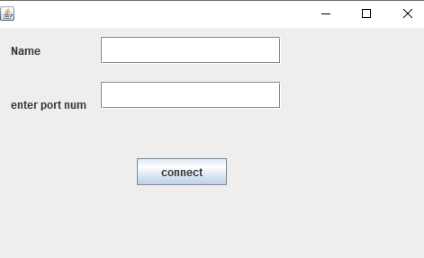

## ***Client***

On the client site the client knows the hostname of the machine on which the server is running and the port number on which the server is listening.

To make a connection request, the client tries to rendezvous with the server on the server's machine and port. The client also needs to identify itself to the server so it binds to a local port number that it will use during this connection. This is usually assigned by the system.

The model used for this project is the single server –

Single client models.

The following specifications must be implemented:

1. The server and client are two separate programs.
2. THE CLIENT SCREEN

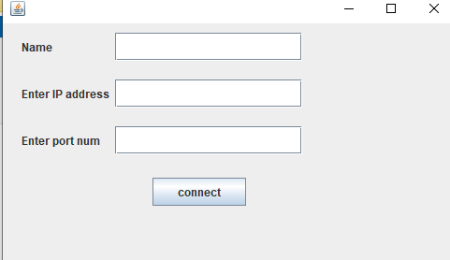

1. THE CLIENT SERVER SCREEN

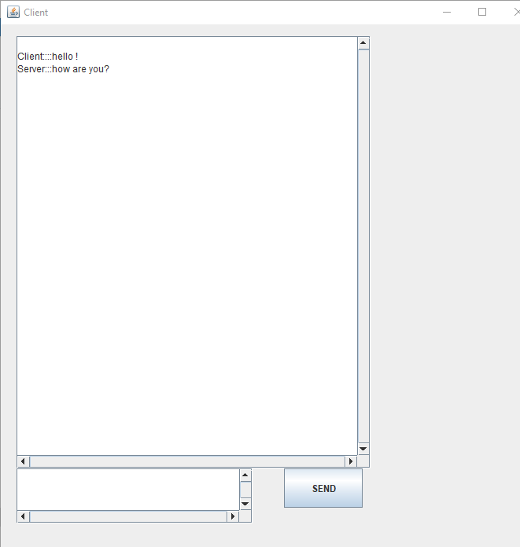

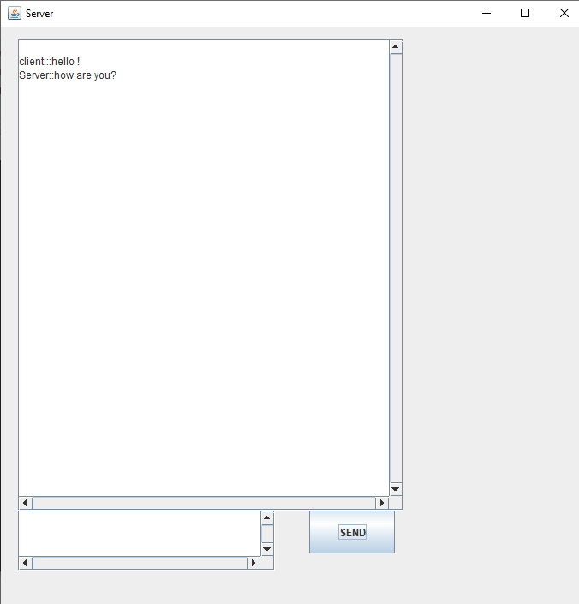

***Future work***

There is always a room for improvements in any software package, however good and efficient it may be done. But the most important thing should be ﬂexible to accept further modification. Right now we are just dealing with text communication. In future this software may be extended to include features such as:

Files transfer: this will enable the user to send files of diﬀerent formats to others via the chat∙ application.

Voice chat: this will enhance the application to a higher level where communication will be∙ possible via voice calling as in telephone.

Video chat: this will further enhance the feature of calling into video communication .

### ***Conclusion***

I Developed network applications in Java by using sockets,

threads, and Web services.

These software is portable, efficient, and easily maintainable for large number of clients. Our developed web-based chatting software is unique in its features and more importantly easily customizable. The java.net package provides a powerful and ﬂexible set of classes for implementing network applications. Typically, programs running on client machines make requests to programs on a server Machine. These involve networking services provided by the transport layer. The most widely used transport protocols on the Internet are TCP (Transmission control Protocol) and UDP (User Datagram Protocol).

TCP is a connection-oriented protocol providing a reliable ﬂow of data between two computers. On the other hand, UDP is a simpler message-based connectionless protocol which sends packets of data known as datagrams from one computer to another with no guarantees of arrival.

***BIBLIOGRAPHY***

The project has been created by the books named:-

* Java and dynamic web page design

-by Dheerendra Kumar Yadav and Vikash Kumar

* Programming with java

-by Balaguruswamy

Google Websites

-javatpoint

-Geeksofgeeks

**THANK YOU**